# Database Design Documentation

* 1. ER Diagram

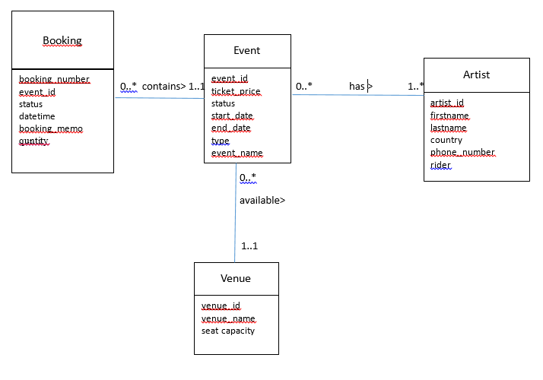

*Pic. 1. ER Diagram*

* 1. Relational Schema and BCNF Validation

**Relational Schema**

Booking ( booking_number, event_id, status, datetime, booking_memo, quantity)

FK(event_id) REFERENCES Event (event_id)

Event (event_id, event_name, type, status, start_datetime, end_datetime, ticket_price, venue_id)

FK(venue_id) REFERENCES Venue (venue_id)

Artist ( artist_id, firstname, lastname, country, phone_number, rider)

Venue (venue_id, venue_name, seat_capacity)

**BCNF**

Booking ( booking_number, event_id, status, datetime, booking_memo, quantity)

Event (event_id, ticket_price, status, start_datetime, end_datetime, type, name, venue_id)

Artist ( artist_id, firstname, lastname, country, phone_number, rider)

Venue (venue_id, venue_name, seat_capacity)

* 1. Database Diagram and Repository

**ENTITY TYPE DESCRIPTIONS**

|  |  |  |  |
| --- | --- | --- | --- |
| **ENTITY TYPE** | **Description** | **Synonyms, aliases** | **Occurrence** |
| Booking | An act of reserving tickets in an online system | Reservation | Customers make bookings several times a day. |
| Event | A planned public cultural activity | Occasion, happening, scene | Events take places several times a month. More often when there is a holiday. |
| Artist | A person who performs in an event | Performer, actor, player | Artists are invited to every events, the most popular artists act more often. |
| Venue | A location where an event takes place | Location, place, space | New venues appear very rarely. |

**ATTRIBUTE TYPE DESCRIPTIONS**

**Booking**

|  |  |  |  |  |  |
| --- | --- | --- | --- | --- | --- |
| **Attribute type** | **Description** | **Data type** | **Value**  **required** | **Identity attribute**  **or part of it** | **Special domain** |
| booking number | Unique number of booking | Integer | Yes | Yes | - |
| event id | Unique number of event | Integer | Yes | - | - |
| status | State of booking | Text | Yes | - | ‘reserved’, ‘refunded’, ‘sold’ |
| datetime | The date and time the booking was made | Datetime | Yes | - | - |
| booking memo | Client’s telephone number | Text | No | - | - |
| quantity | Number of tickets | Integer | Yes | - | - |

**Event**

|  |  |  |  |  |  |
| --- | --- | --- | --- | --- | --- |
| **Attribute type** | **Description** | **Data type** | **Value**  **required** | **Identity attribute**  **or part of it** | **Special domain** |
| event id | Unique number of event | Integer | Yes | Yes | - |
| ticket price | Amount of money needed to be paid for a single ticket | Float | Yes | - | - |
| status | State of an event | Text | Yes | - | ‘Cancelled’, ‘running’ |
| start datetime | Date and time an event starts | Datetime | Yes | - | - |
| end datetime | Date and time an event ends | Datetime | Yes | - | - |
| type | Kind of performance | Text | Yes | - | - |
| name | Title of a performance | Text | Yes | - | - |
| venue id | Unique number of venue | Integer | Yes | - | - |

**Venue**

|  |  |  |  |  |  |
| --- | --- | --- | --- | --- | --- |
| **Attribute type** | **Description** | **Data type** | **Value**  **required** | **Identity attribute**  **or part of it** | **Special domain** |
| venue id | Unique number of venue | Integer | Yes | Yes | - |
| venue name | Title of a location | Text | Yes | - | - |
| seat capacity | Number of available places | Integer | Yes | - | - |

**Artist**

|  |  |  |  |  |  |
| --- | --- | --- | --- | --- | --- |
| **Attribute type** | **Description** | **Data type** | **Value**  **required** | **Identity attribute**  **or part of it** | **Special domain** |
| artist id | Unique number of artist | Integer | Yes | Yes | - |
| firstname | Name of a performer | Text | Yes | - | - |
| lastname | surname of a performer | Text | No | - | - |
| country | Name of country a performer came from | Text | Yes | - | - |
| phone number | Artist’s telephone number | Text | Yes | - | - |
| rider | Catering and refreshments requirements of an artist | Text | No | - | - |

**TABLE DESCRIPTIONS**

**Booking**

|  |  |  |  |  |  |
| --- | --- | --- | --- | --- | --- |
| **Attribute type** | **Description** | **Data type** | **Value**  **required** | **Keys** | **Special domain** |
| booking_number | Unique number of booking | INTEGER | Yes | PRIMARY KEY (UNIQUE) | - |
| event_id | Unique number of event | INTEGER | Yes | - | - |
| status | State of booking | VARCHAR(50) | Yes | - | ‘reserved’, ‘refunded’, ‘sold’ |
| datetime | The date the booking was made | DATETIME | Yes | - | - |
| booking_memo | Client’s telephone number | VARCHAR(13) | No | - | - |
| quantity | Number of tickets | VARCHAR(30) | Yes | - | - |

**Event**

|  |  |  |  |  |  |
| --- | --- | --- | --- | --- | --- |
| **Attribute type** | **Description** | **Data type** | **Value**  **required** | **Keys** | **Special domain** |
| event_id | Unique number of event | INTEGER | Yes | PRIMARY KEY (UNIQUE) | - |
| ticket_price | Amount of money needed to be paid for a single ticket | FLOAT | Yes | - | - |
| status | State of an event | VARCHAR(50) | Yes | - | ‘cancelled’, ‘running’ |
| start_datetime | Date and time an event takes place | DATETIME | Yes | - | - |
| end_datetime | Date and time an event takes place | DATETIME | Yes | - | - |
| type | Kind of performance | VARCHAR(50) | Yes | - | - |
| name | Title of a performance | VARCHAR(50) | Yes | - | - |
| venue_id | Unique number of venue | INTEGER | Yes | - | - |

**Venue**

|  |  |  |  |  |  |
| --- | --- | --- | --- | --- | --- |
| **Attribute type** | **Description** | **Data type** | **Value**  **required** | **Keys** | **Special domain** |
| venue_id | Unique number of venue | INTEGER | Yes | PRIMARY KEY (UNIQUE) | - |
| venue_name | Title of a location | VARCHAR(50) | Yes | - | - |
| seat_capacity | Number of available places | INTEGER | Yes | - |  |

**Artist**

|  |  |  |  |  |  |
| --- | --- | --- | --- | --- | --- |
| **Attribute type** | **Description** | **Data type** | **Value**  **required** | **Keys** | **Special domain** |
| artist_id | Unique number of artist | INTEGER | Yes | PRIMARY KEY (UNIQUE) | - |
| firstname | Name of a performer | VARCHAR(50) | Yes | - | - |
| lastname | surname of a performer | VARCHAR(50) | No | - | - |
| country | Name of country a performer came from | VARCHAR(50) | Yes | - | - |
| phone_number | Artist’s telephone number | VARCHAR(13) | Yes | - | - |
| rider | Rider of an artist | VARCHAR(50) | No | - | - |

**Event_Artist**

|  |  |  |  |  |  |
| --- | --- | --- | --- | --- | --- |
| **Column** | **Description** | **Data type** | **Value required** | **Keys** | **Special domain** |
| event_id | *Unique event identifier* | INTEGER | Yes | IN PRIMARY KEY  FOREIGN KEY 1  => Event | - |
| artist_id | *Unique artist identifier* | INTEGER | Yes | IN PRIMARY KEY  FOREIGN KEY 2  => Artist | - |